CLOUD COMPUTING LAB

KUBERNETES

NAME : SIRI GOWRI H

SRN : PES1UG21CS599

SEC. : J

**TASKS:**

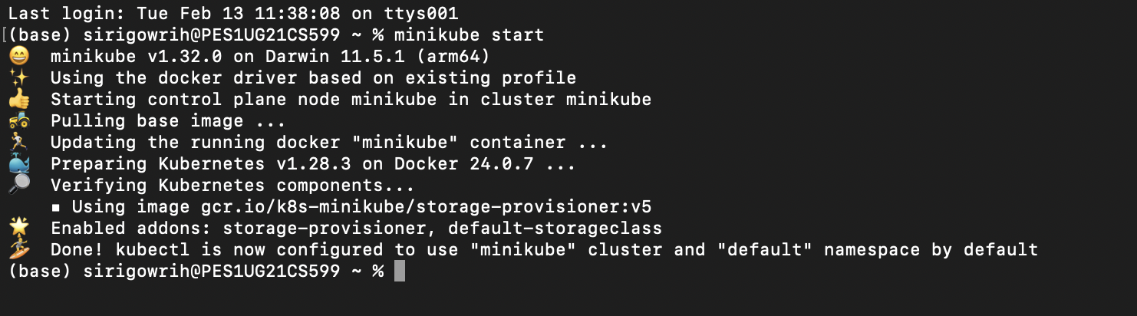**Task-1: After installation of both kubectl and minikube.**

**Task-2: Creating pods and deployments, editing them and observing Rollback.**

✓ **SCREENSHOT 2a: Get nodes, pods, services.**

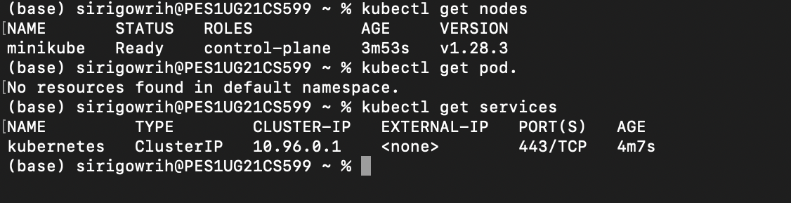

✓ **SCREENSHOT 2b: Deployment Created (with SRN)**



✓ **SCREENSHOT 2c: Get deployment and pod.**

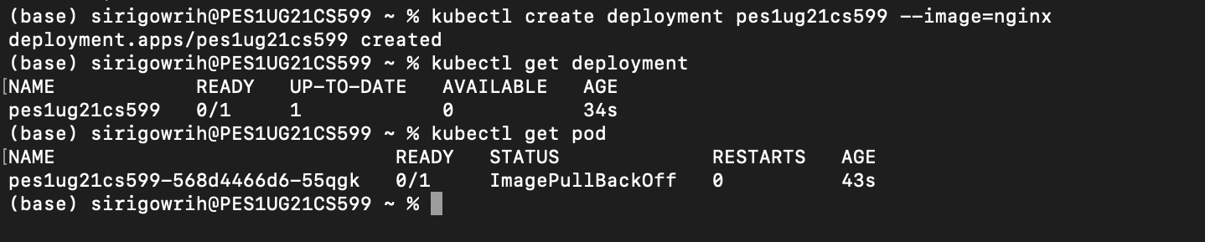

✓ **SCREENSHOT 2d: Editing ‘-image:nginx’**

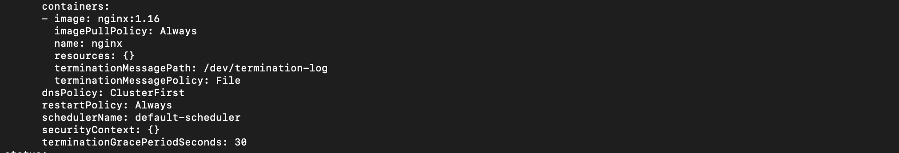

✓  **SCREENSHOT 2e: Showing edited deployment.**



✓  **SCREENSHOT 2g: Changes after rolling back to original.**



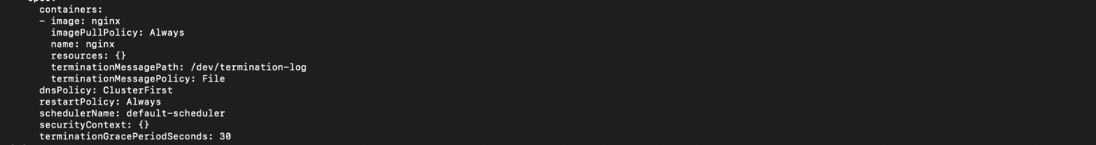

**Task-3: Debugging Pods.**

✓**SCREENSHOT 3a: Kubectl logs displayed**

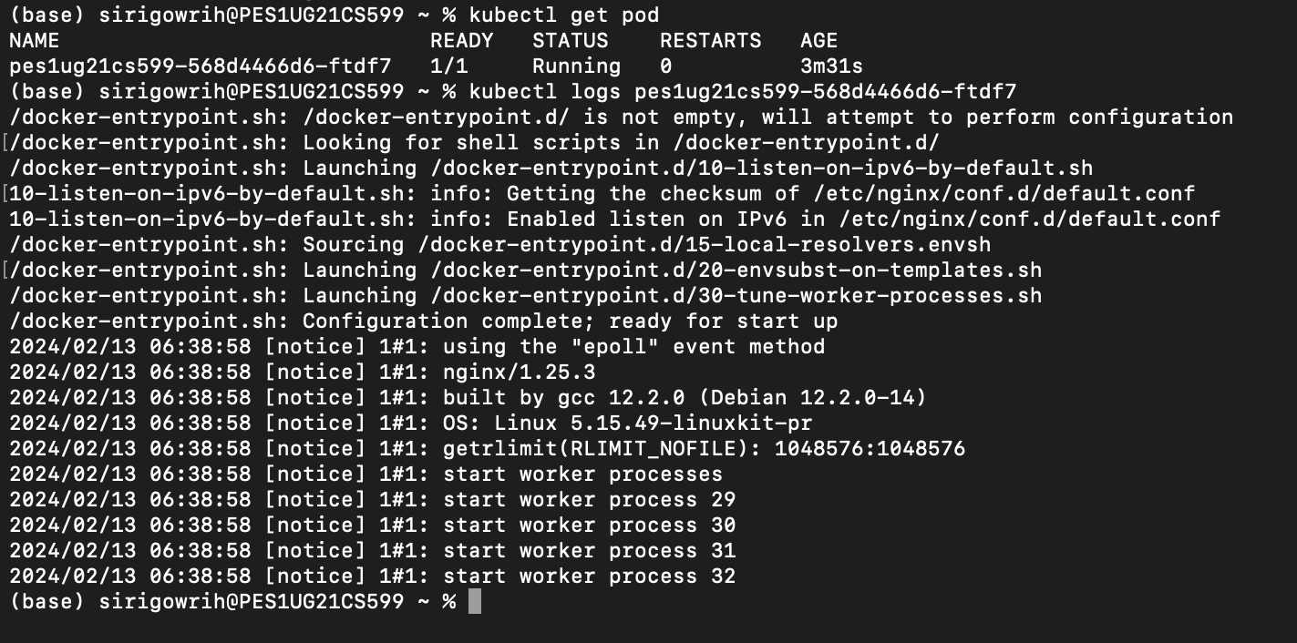

✓ **SCREENSHOT 3b: Kubectl ‘describe pod’ command – Screenshot of “events” section**

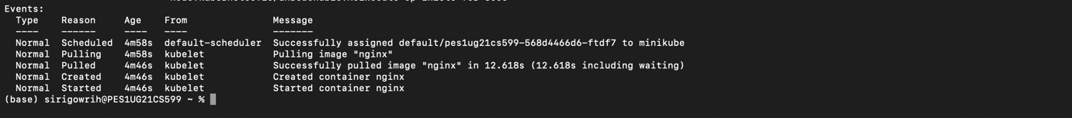

✓**SCREENSHOT 3c: Creating mongo deployment**



✓**SCREENSHOT 3d: Deleting both requirements.**



**Task-4: Applying configuration files.**

✓**SCREENSHOT 4a: Kubectl apply command on yaml file.**

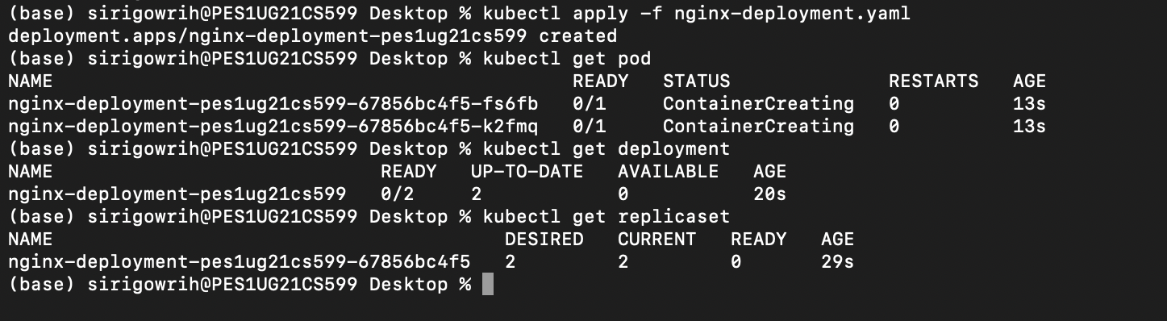

✓**SCREENSHOT 4b: Kubectl get on yaml file.**

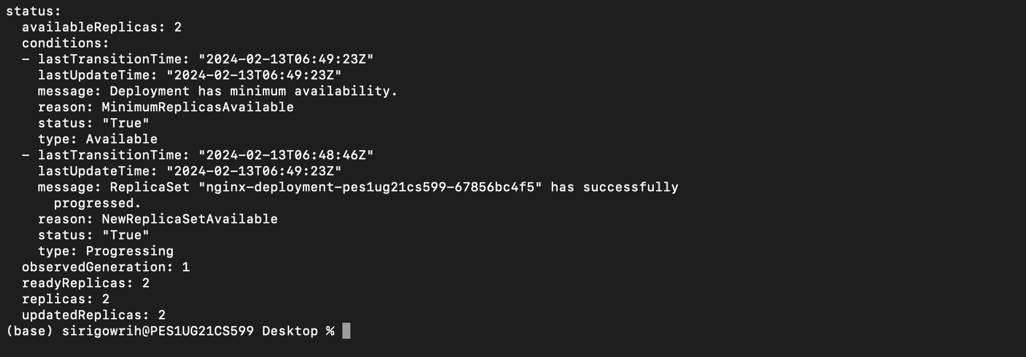

**Task-5: Delete a pod to observe the self-healing feature.**

✓**SCREENSHOT 5a: Delete pod.**

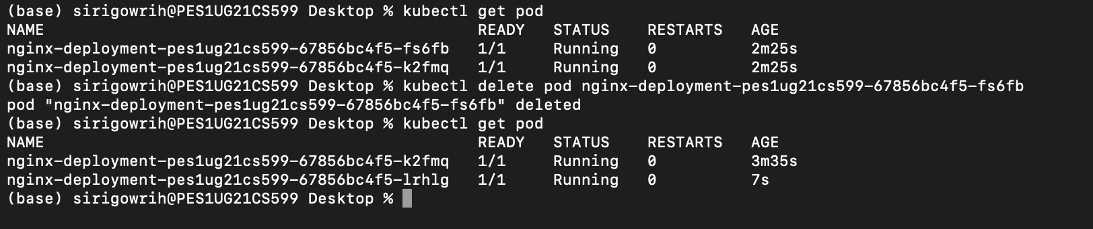

**Task-6: Connecting Services to Deployments.**

✓**SCREENSHOT 6a: Kubectl apply and get command.**

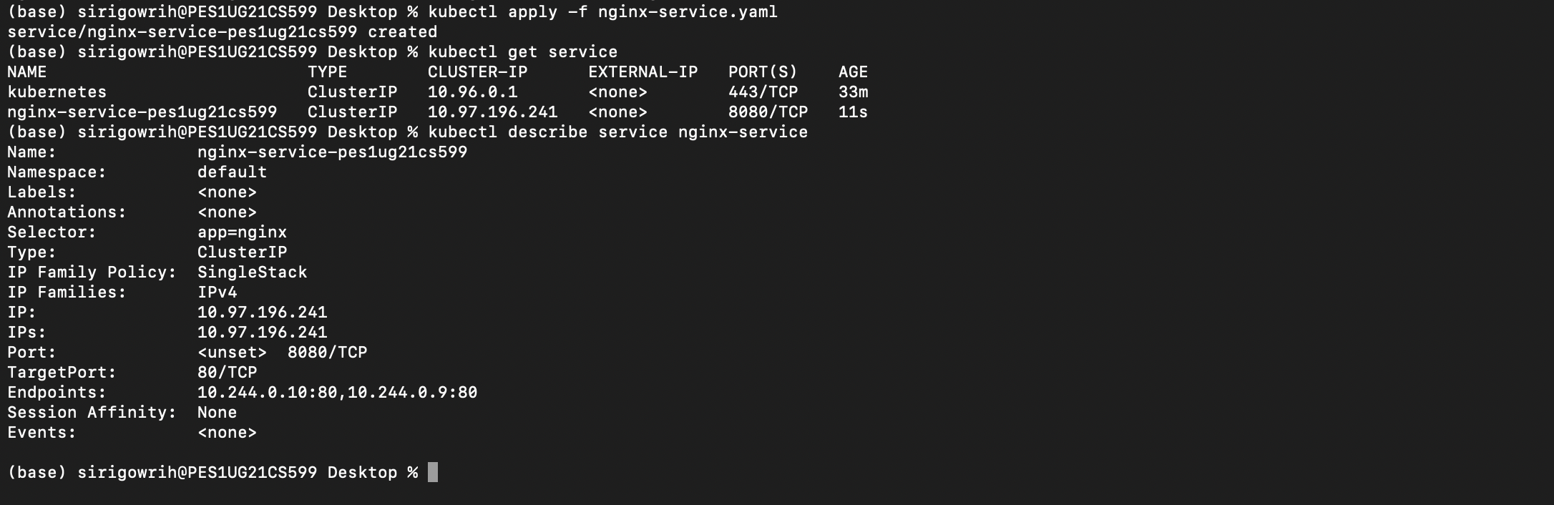

✓**SCREENSHOT 6b: kubectl get pod -o wide command.**



**Task-7: Port Forwarding.**

✓**SCREENSHOT 7a: Kubectl port-forward command .**



✓**SCREENSHOT 7b: Display welcome to nginx on web page.**

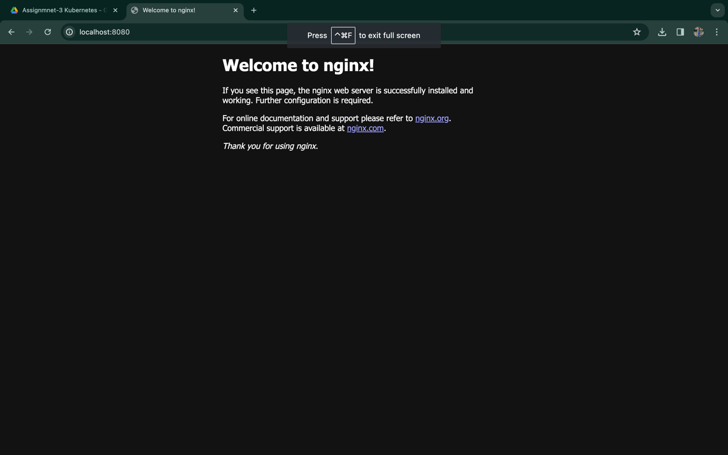

**Task-8: Deleting service/deployment and Cleanup.**

✓**SCREENSHOT 8a: Delete nginx deployments.**

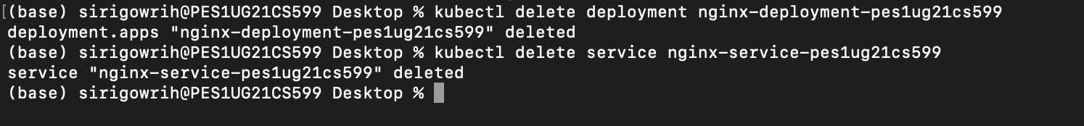

✓**SCREENSHOT 8b: Minikube stop – Do this after the 9th Task.**

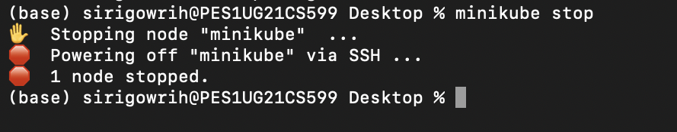

**Task-9: Expose an external IP address to access an Application in a cluster (To be done by the student).**

✓**SCREENSHOT 9a: The command which exposes specifies the type of service (NodePort/LoadBalancer)**



✓**SCREENSHOT 9b: kubectl get service command which displays the node port**



✓**SCREENSHOT 9c: minikube IP address**



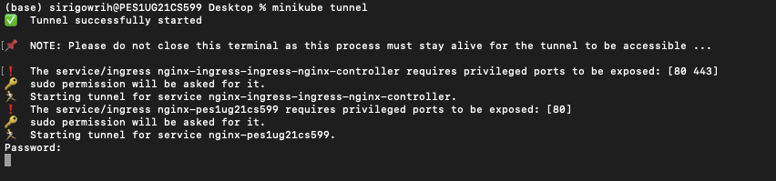

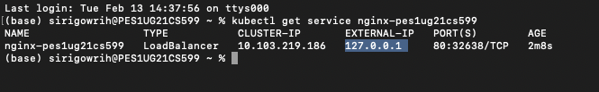

✓ **SCREENSHOT 9d: the webpage with the IP Address visible. (If the IP Address is not visible in the screenshot, you will lose significant portion of marks w.r.t. Section 9)**

